Exam of Digital Communications
a.a. 2019-2020
Feb 03, 2020

Exercise #1
The spectrum of a lowpass signal is shown below:
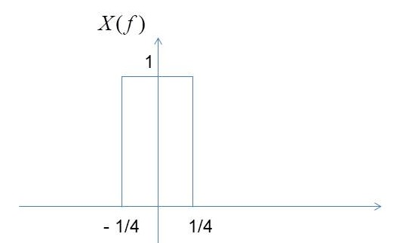

- Determine the value of the Nyquist sampling rate, fs,min.
- Sketch the ideal sampled spectrum Xδ(f), for the sampling rate fs = 2fs,min
- Sketch the spectrum of the complex envelope of the output of an ideal (rectangular) bandpass filter with f0 = 2, B = 0.6, and gain 1/4.

Exercise #2
A message signal m(t) is transmitted by binary PCM. Let the signal to-quantization noise (SQNR) required be at least 46 dB. Determine the minimum number of bit required to encode each sample, assuming that m(t) is sinusoidal. With this value of quantization levels, determine the SQNR.

Exercise #3
The two pulses shown in the figure below are employed in a binary signaling
scheme to be used in a digital communication system with AWGN channel with noise energy N0/2.
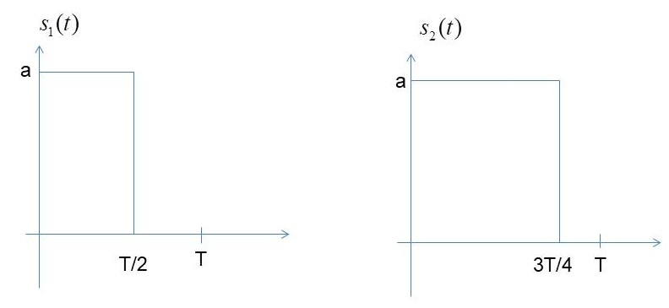

- Calculate the average energy per bit
- Sketch carefully the optimum receiver (and the impulse response of the filters are included in the receiver).
- Write the expression of the probability of error as a function of the energy per bit
- Compare the achieve probability of error with the probability of error of an antipodal binary transmission scheme with the same energy per bit

Exercise #4
A bandpass QPSK modulation system uses the following orthonormal signals:

The noise is AWGN with N0 = 1 and the target probability of a bit error is Pb = 10−5.

- Determine the maximum bit rate of the system (bps)
- The channel bandwidth is 450Hz and a raised cosine spectrum is employed to eliminate ISI. Determine the excess bandwidth and sketch carefully the spectrum
- Draw the constellation points

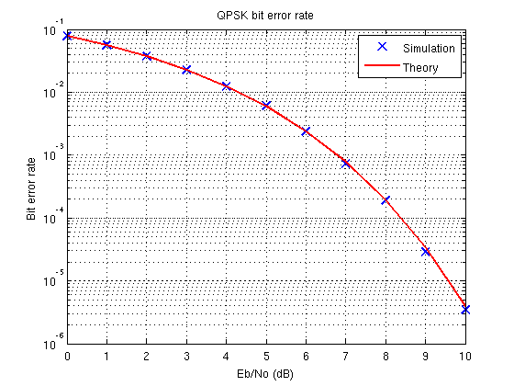

Exercise #5
In the design of a satellite geostationary link, what would you choose between an 8QAM or 8PSK constellation? Explain your answer.
If the previous link is designed for very high frequency bands (higher than 20GHz) in clear sky conditions. Given that the atmospheric precipitations cause signal degradation (lower SNR), to close the link when it rains, you have to use another modulation. Which one between QPSK and 16QAM? Explain your answer.

